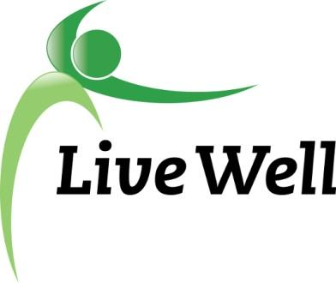
AGENDA

Healthy Food for All Work Group
Virtual Meeting via Google Hangouts: meet.google.com/khm-drvc-owq

2:00pm – 3:30pm, Thursday, April 22nd.

Agenda items | Notes | Action Items
Introductions | - Welcome everyone! Introductions, Accomplishments, and Ice Breaker: HAPPY EARTH DAY! What’s your favorite place you’ve visited? | Jessica Cooney, Ryan Bowersox, Michaela Cantrell, Celia Ruiz, Jamie Hofling, Kate LaRosh, Kim Culliss, Laura McCulloch, Michele Dillon, Nancy O’Connor, Nathan Howard, Kim Criner, Susan Farley, Frankie Haynes, Rebecca Collier, Norm White, Cierra Smallwood, Allison Koonce, Marty Scott, Kelsey Fortin
Announcements | - Continuation of CHIP goal discussion from February meeting  - “By 2023, increase the number of schools that make policy changes to allow fruit and vegetable consumption throughout the school day (pending)”  - Summer Meal Program?  - BCBS Packages - Marty  - Transit Hub | - CHIP  - Billy Mills “CSA” boxes through their garden w/Just Food  - What's the measurement  - Availability/Access vs consumption term change  - Baseline- produce already going to pantries from Just Food, pounds of produce per school  - Farm to school records? Weights from USD 497, how tracking differs school to school, weights and destinations, infrastructure: scales  - fresh produce only or canned/frozen as well to consider in determinants.  - Maybe only use Billy Mills as a pilot until 2023 until determinants are figured out  - Lay groundwork for consumption in kids  - Summer Meals  - distribution sites & activities coming soon  - Any kid zero to 18  - BCBS  - packages are moving well  - quarterly: what's working, challenges, needed resources  - Send photos  - DUFB- flyers  - https://www.doubleupheartland.org/wp-content/uploads/2021/04/2021-Kansas-DUFB-locations-8.5x14-printer-friendly.pdf  - Simply Produce in the fall  - Cruising Cupboard- Texting service, door hangers,  - Prescription Pad- survey to providers, good feedback, incentivize, postcard size, updating information for summer food sites, provider partnerships  - Harvesters Food Locator: https://www.harvesters.org/Get-Help  - Incentivize: providing a (electric) skillet, knives, cutting boards,basic tools/equipment, ingredients like spices, healthy oils, etc.  - Transit  - Multimodal transfer facility, Bob Billings and Crestline  - Just Food delivery: unwillingness to get bus passes; Just Food Cruising Cupboard- come only to bus @ library and not to the building  - Accessibility/Mobility challenges  - Time  - Two bag limit on the bus/ heavy items/ item load  - Bus carts @ Just Food: take food out of the cart and fold the cart up  - Transfers - time, taking food on the bus  - Express line for grocery stores w/places to put food
Sharing of Resources/ Community Needs | - Covid Resources: To see if you have correctly filled out the Vaccine Interest Form, you can search for the record here: dgcoks.org/vaccineinterestformsearch. This list of names will be updated at 11 a.m. weekdays (Monday-Friday). If no record is found, please fill out the form again. Here's the link: dgcoks.org/vaccineinterestform.
HFFA Leadership Transition | - New chairs? July transition.
On-Going Projects
Adjourned | - Next Meeting - May 27th, 2-3:30pm

